The Software Engineering Meetings You Actually Need
Nobody likes poorly run meetings OR too many meetings. A well-crafted set of well-defined meetings, though, can make a software engineering team more efficient by ensuring that they build the right thing at the right time.

Retrospective
The regular team retrospective is how your team gets better; therefore, it's the most important regular meeting your team has. Usually, a team just starting to do retrospectives has a lot of ideas for improvement, so this can take a while. This is Totally fine; you're investing 90 minutes every two weeks to improve your team.
Once you're up and running and things are going smoothly, you'll end up with a retro every four to eight weeks, depending on how much change is happening around your team.
Everyone on the team should attend the retrospective regardless of the nature of their role.

Interval planning
Interval planning (also called sprint planning) is how your team decides what it's going to do on a week-by-week basis. This is where the team accepts work from the inbox, points and schedules work on their backlog, gets business context from their lead and/or manager, and sets up their goals for the interval. Interval planning should happen once per week for one hour.
Daily standup
This is a 15 minute meeting that happens once per working day, designed to raise blocking issues and allow for tactical planning.
1:1 between staff and manager
Every person on the team should have a scheduled, one-hour meeting with their manager that happens at least every two weeks. 10 AM is a good time for this. This is not a status meeting; this is for staff to have time with their manager to discuss problems, planning, career progress, and other issues. The staff owns the meeting and runs the agenda.
Only the manager and the staff member should attend.

Brainstorm / design doc / decision trio
When the next task on the team's list is "figure out what the hell we're going to do to solve this problem", this is a good tool.
Call a brainstorm meeting: anybody on the team who's "involved" should attend with the goal of getting as many options on the table as possible. The person who's "committed" collects the results and generates a design document which do not need to be formal.
Once the design doc is finished, it should be sent to the team and a deadline provided for feedback.
Once feedback has been collected, the author of the design doc should integrate it into their design and re-send the final doc to the team and schedule a decision meeting with the team as soon as possible.
In the decision meeting, the design doc is assumed to have already been read by the team members, and the team chooses to either accept the proposed design, accept one of the alternatives, or reject the design and start over.

Requirements validation is the process of checking that requirements defined for development, define the system that the customer really wants. To check issues related to requirements, we perform requirements validation. We usually use requirements validation to check errors at the initial phase of development as the error may increase excessive rework when detected later in the development process. In the requirements validation process, we perform a different type of test to check the requirements mentioned in the Software Requirements Specification (SRS), these checks include:
- Completeness checks
- Consistency checks
- Validity checks
- Realism checks
- Ambiguity checks
- Verifiability

Verification and Validation is the process of investigating that a software system satisfies specifications and standards and it fulfills the required purpose.
Barry Boehm described verification and validation as the following:
Verification: Are we building the product, right?
Validation: Are we building the right product?

Verification and validation: What’s the difference?
As you consider validation vs. verification, you might feel unsure about the differences. What activities fall under the category of validation and which fall under verification, and when should you perform each?
Let’s say that you’re working to create a product and it’s time for verification testing since verification always comes first. During this process, you check documents, design, code, and the program to make sure the software is built according to requirements. The goal is to ensure the quality of the application or design. You might conduct activities such as reviews, walkthroughs or inspections. For example, in the Medical Device Industry, verification usually happens with the “design equivalent” configuration of the product. Validation usually happens with the “production equivalent” of the product per 820.30(g).
Now, it’s time to move on to validation. During this process, you’re testing and validating whether the product meets the needs of your customer. Tasks in this process may include unit testing, integration testing or user testing. As we stated at the top of this article, the verification process ensures that software meets specifications. Validation focuses on whether the software meets the expectations and requirements of the end-user.

Verification:
Verification is the process of checking that a software achieves its goal without any bugs. It is the process to ensure whether the product that is developed is right or not. It verifies whether the developed product fulfills the requirements that we have.
Verification is Static Testing.

Activities involved in verification:
- Inspections
- Reviews
- Walkthroughs
- Desk-checking
Validation:
Validation is the process of checking whether the software product is up to the mark or in other words product has high level requirements. It is the process of checking the validation of product i.e. it checks what we are developing is the right product. it is validation of actual and expected product.
Validation is the Dynamic Testing.
Activities involved in validation:
- Black box testing
- White box testing
- Unit testing
- Integration testing

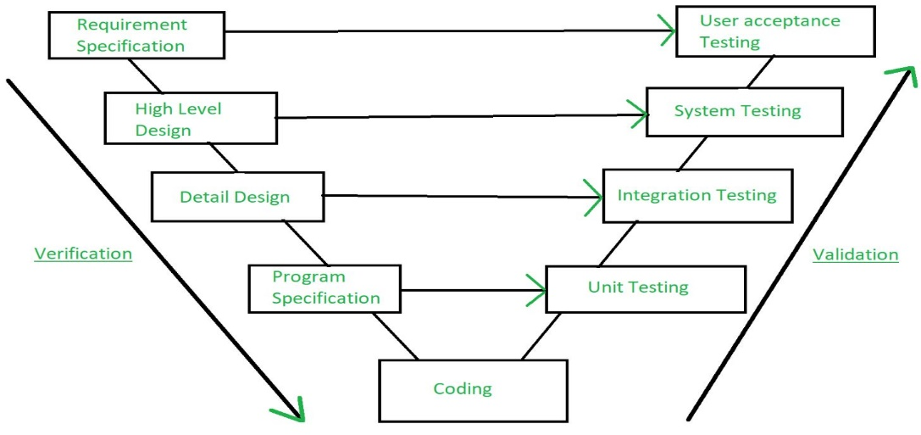

Learn the questions from page number 479 , Exercise 17.6,17.7 and 17.8. (BOOK 3)

